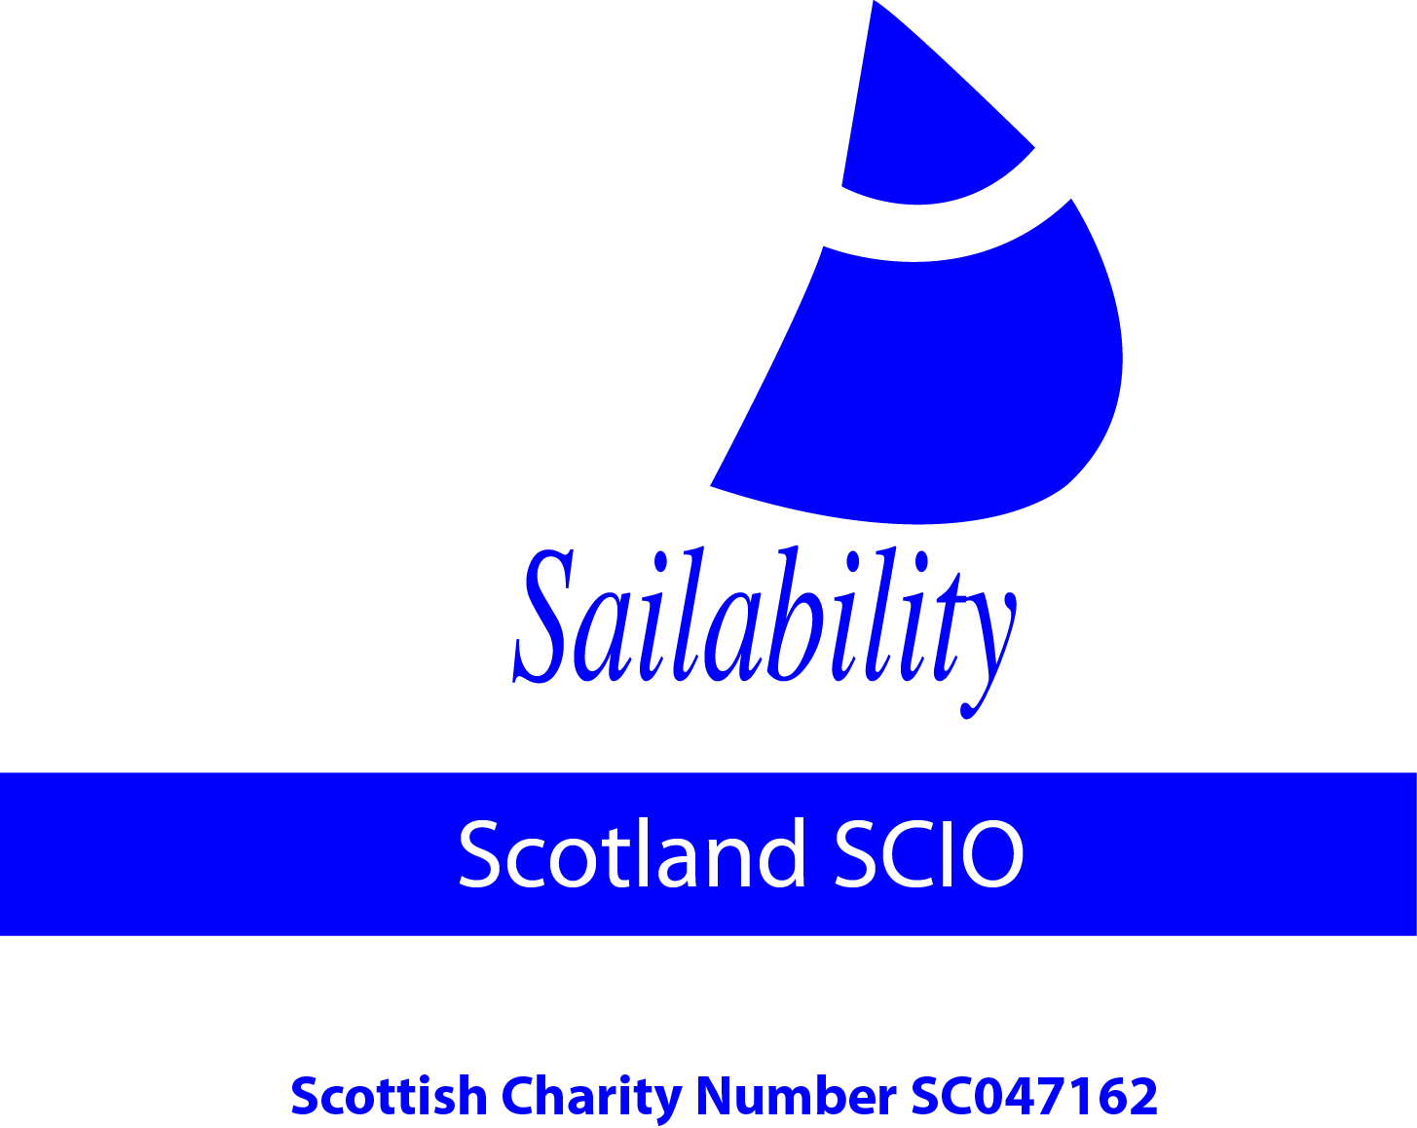 | Sailability Scotland

Sailability Scotland SCIO (SC047162) continues to encourage and support people with disabilities to take up the sport and facilitate sites to develop sailing opportunities.

On 1st September .......................................... will be part of a fleet of sail boats attempting to circumnavigate the Isle of Shuna off the West coast of Scotland to support Sailability Scotland SCIO

Sponsor’s Full Name  (First name & surname) | Sponsor’s Home address  Only needed if are Gift Aiding your donation.  Don’t give your work address if you are Gift Aiding your donation. | Postcode | Donation Amount  £ | Date paid | Gift Aid?  ✔

Sponsor’s Full Name  (First name & surname) | Sponsor’s Home address  Only needed if are Gift Aiding your donation.  Don’t give your work address if you are Gift Aiding your donation. | Postcode | Donation Amount  £ | Date paid | Gift Aid?  ✔

Sponsor’s Full Name  (First name & surname) | Sponsor’s Home address  Only needed if are Gift Aiding your donation.  Don’t give your work address if you are Gift Aiding your donation. | Postcode | Donation Amount  £ | Date paid | Gift Aid?  ✔
 | Total donations received | £
 | Total Gift Aid donations | £
 | Date donations given to Charity

